How to use our self-study courses
This is a step-by-step guide on how to open the zip files through which we provide our self-study courses Virtual Collaboration and Intercultural Competence.

1. Download
Download the zip file from our website and save it locally.

2. Unzip
Open the file explorer and find the zipped folger. It is important to unzip the entire folder. To do so, right-click on the zip file and select Extract all. Follow the instructions.

3. Open Story.hmtl
Use your file explorer again and find the extracted folder. Open the folder, and then open the file Story.html in your internet browser. You can now start the self-study course.
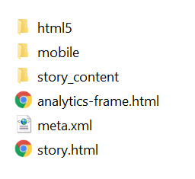

Contact
This guide was created by Vicky Großkreuz and Maximilian Köster / Digital Mobil @ FH Bielefeld. It is licensed under CC BY-SA 4.0.
If you have any questions, please contact digitalmobil@fh-bielefeld.de.
Bielefeld University of Applied Sciences
Digital Mobil @ FH Bielefeld
Interaktion 1
33619 Bielefeld, GERMANY
Digital Mobil @ FH Bielefeld is funded by the German Academic Exchange Service (DAAD) und and the Federal Ministry of Education and Research (BMBF).

